**Local Feature Matching using the SIFT algorithm**

***CIE 552 Mini project 2***

Khaled ElBastawisy 201800029

Mohamed Khalil 201801898

1. 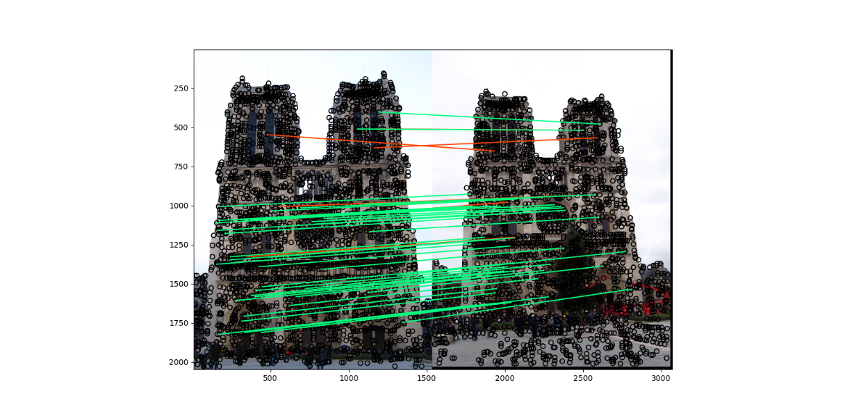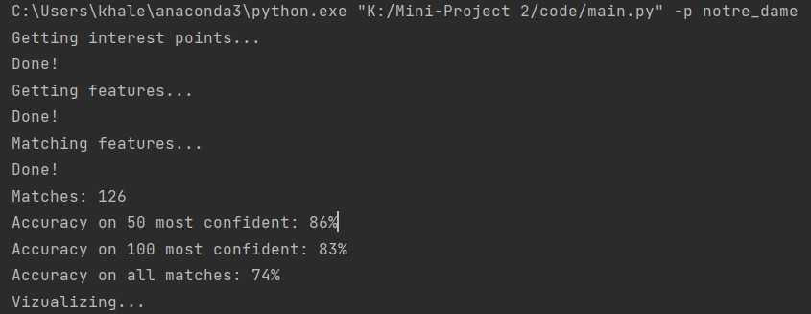Results using the Notre Dame Image pair
2. 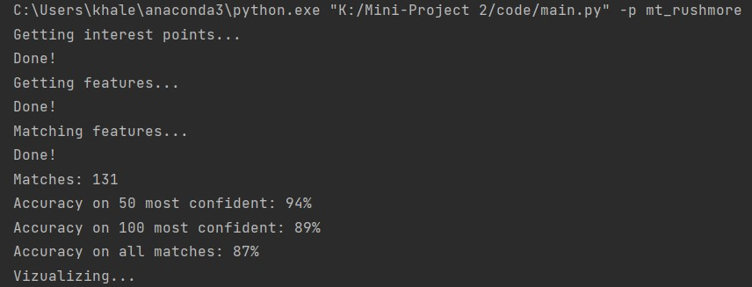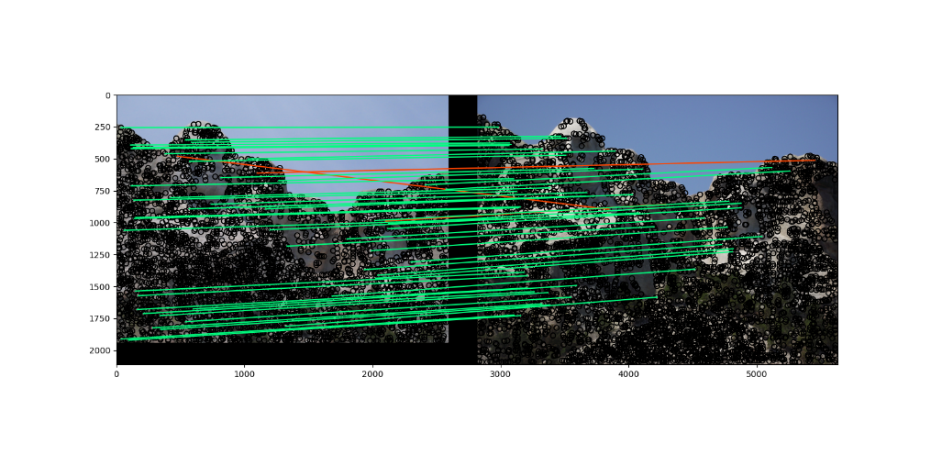Results using the Mt. Rushmore image pair
3. 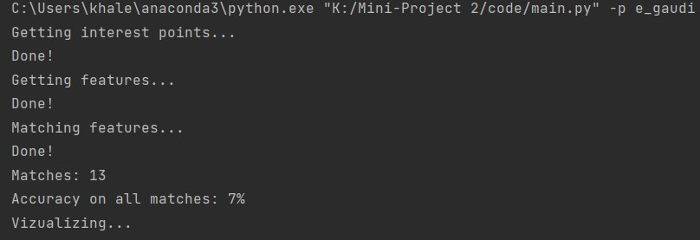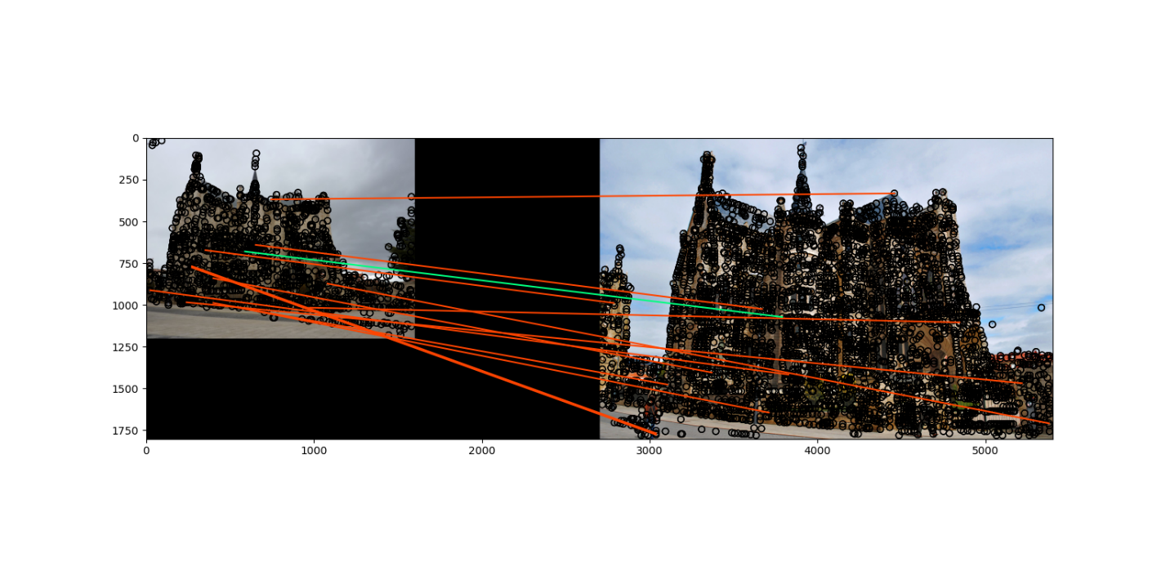Results using the Episcopal Gaudi image pair